**Time Series Analysis**

**Time Series:** an ordered sequence of values of a variable at equally spaced time intervals.

* Time series allows to replicate every element of the process by decomposing the mathematic process into a combination of signals and noise (random probabilistic processes), without knowing the underlying causes.

* Statistical moments
  + Mean and standard deviation (statistical moment) -> may change over time
    - Mean is varying but oscillation around the mean looks constant

* + Constant mean, changing sdv. (‘volatility’)

* + Time series is different from a group of a random variable with a known mean and sdv.
    - x(t) depends in any significant way on the value of x(t-1) -> memory
* Stationary and non-stationary
  + Trends in mean/sdv.
* Seasonality
  + Periodic patterns
* Autocorrelation
  + Degree to which time series values in period (t) are related to time series values in periods (t+1, t+2…)

**Pre-processing and Filtering**

* Filtering -> deconstructing the time into its component parts
  + Detrending
    - Non-stationarity
      * Mean is changing -> change to constant mean
        + If detrending is not sufficient to make the series stationary -> transform it into a series of period-to-period/ season-to-season differences -> **difference-stationary**
        + If first difference is also random -> ‘**random walk model**’ (each value is random away from the previous value)

white noise

* + - Seasonality
      * Subtract seasonal signals and to check if it’s a random process
  + Autocorrelation
    - Quantify the ‘memory’ as autocorrelation
      * Measuring the correlation between a time series and itself at different “lags” (shifts in time)

* + - * Test autocorrelation as many lags, depending on the length of the time series -> plotting autocorrelation as a function of lag -> choose lags to let it be statistically independent
    - Purpose
      * To detect non-randomness in data
      * To identify an appropriate time series model if data are not random
  + Outliers
  + ‘Low Pass’ filters
    - Smoothing ->producing a time series in which the importance of the spectral components at high frequencies is reduced (‘**low-pass filter**’) -> but will lose data

* + - * Moving average
      * Exponential
* White noise <- after eliminating all elements of ‘signals’ (trends, periodicity, autocorrelation)
  + Random process, whose samples are regarded as a sequence of serially uncorrelated random variables with zero mean and finite variance
  + It can be replicated by simply sampling from an appropriate statistical distribution with replacement

**Time Series Modelling**

**Applications**

* Understanding of underlying forces and structure that produced the observed data
* Fit a model and proceed to forecasting, monitoring or even feedback and feedforward control
* Autoregressive (AR) model
  + Capture the autocorrelated processed with random components
    - is time series, is white noise
    - The response variable in the previous time period has become the predictor
    - First-order autoregression AR(1)
    - A kth-order autoregression (AR(k)), is a multiple linear regression in which the value of the series at any time t is a linear function of the values at time t-1, t-2…t-k
  + Choose k -> potting autocorrelation vs lags (shows the memory of time series process decaying over time)

* + Partial Autocorrelation Function (PACF)
    - The partial autocorrelation at lag k is the autocorrelation between and
    - In theory, the PAC od AR(k) process should be zero at lag k+1 and greater

* Moving Average (MA) Model
  + Past error (multiplied by a coefficient)
    - is normally distributed with mean 0 and same variance
    - For MA(1)
      * Autocorrelation function (ACF)
* Autoregressive Intergraded Moving Average (ARIMA) Model
  + Combine of AR and MA models <- no differencing is involved
  + ARIMA representation = (AR order, differencing, MA order)
    - AR(2) -> (2,0,0)
    - MA(2) -> (0,0,2)
    - 1 AR term, a first difference, and 1 MA term -> (1,1,1)
  + Identify the structure
    - Time series plot of data
      * If there’s trend, a linear detrend of first difference may be needed, the data can be smoothed if , necessary
    - ACF/ PACF
      * If all autocorrelations are non-significant -> series is random (white noise; order matters but the data are i.i.d) -> done

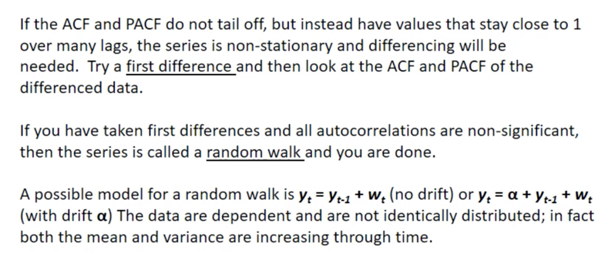

**Model Fitting**

PCAF -> identify number of correct order or number of lags for an AR model

ACF -> identify the number of lags for MA model

Model only involves autoregressive terms -> AR model

Model only involves moving averge terms -> MA model

No differencing is involved -> ARIMA